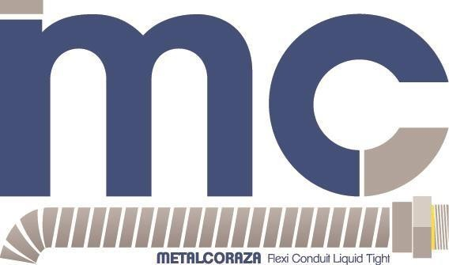

CONECTORES RECTOS Y CURVOS LIQUID TIGHT ZINC DIE CAST

Referencia | Conector Recto | Unidad de Empaque | Conector Curvo | Unidad de Empaque
3/8” | $ 4.364 | 400 | $ 6.656 | 200
1/2” | $ 4.325 | 250 | $ 6.668 | 200
3/4” | $ 6.312 | 250 | $ 9.040 | 125
1” | $ 9.241 | 144 | $ 14.090 | 100
1-1/4” | $ 14.187 | 100 | $ 29.036 | 50
1-1/2” | $ 18.981 | 100 | $ 33.547 | 50
2” | $ 23.630 | 50 | $ 54.826 | 20
2-1/2” | $ 58.028 | 27 | $ 120.507 | 15
3” | $ 81.745 | 18 | $ 155.157 | 10
4” | $ 138.030 | 10 | $ 226.841 | 5

Precios + 19% IVA

ENERO 04/2022

